Join us for one of 4 Chicagoland screenings of:

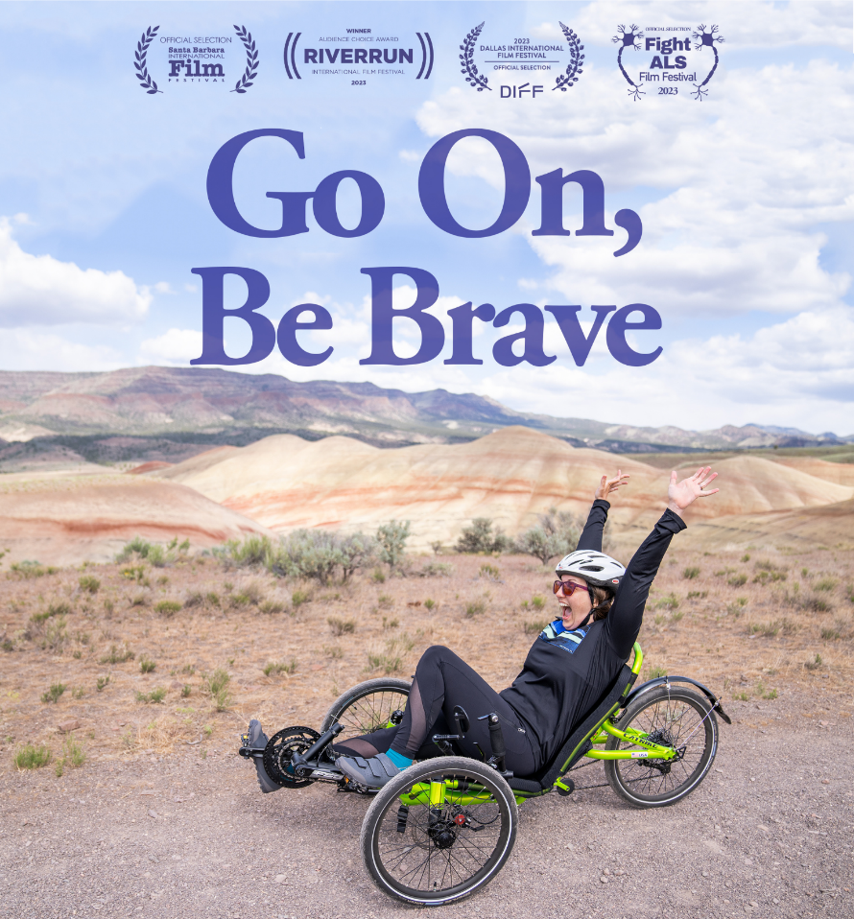
Thursday, October 5,
7:00 p.m. at Grace

Tickets available on
Grace’s website GraceGlenEllyn.org, by calling 630-469-1555, or by scanning here:
Go On, Be Brave is the story of Andrea Lytle Peet's race against time and an attempt at the impossible - to be the first person with ALS to complete a marathon in all 50 states.
“A joyous ride we all need to take!”
- Unseen Films

The film is a love letter to the ALS community that refuses to be defined by their diagnoses and says, “You can steal everything from us, but you cannot steal our spirit.” It is a love story between Andrea and Dave –
a deep and abiding love that refuses to give up.
This is not a “sports” or “disease” documentary.
It inspires the audience to answer a universal question…
What does it mean to truly live?

Meet Andrea, her husband Dave,
and the film’s directors Miriam McFadden and Brian Beckman
at a Q&A following the screening.

General Admission $15 / Seniors $5 / 15 and under free.
Proceeds benefit research to find a cure for ALS.

