Grace Lutheran Church

493 Forest Avenue, Glen Ellyn IL 630.469.1555
www.graceglenellyn.org

4th Sunday after Pentecost June 16, 2024

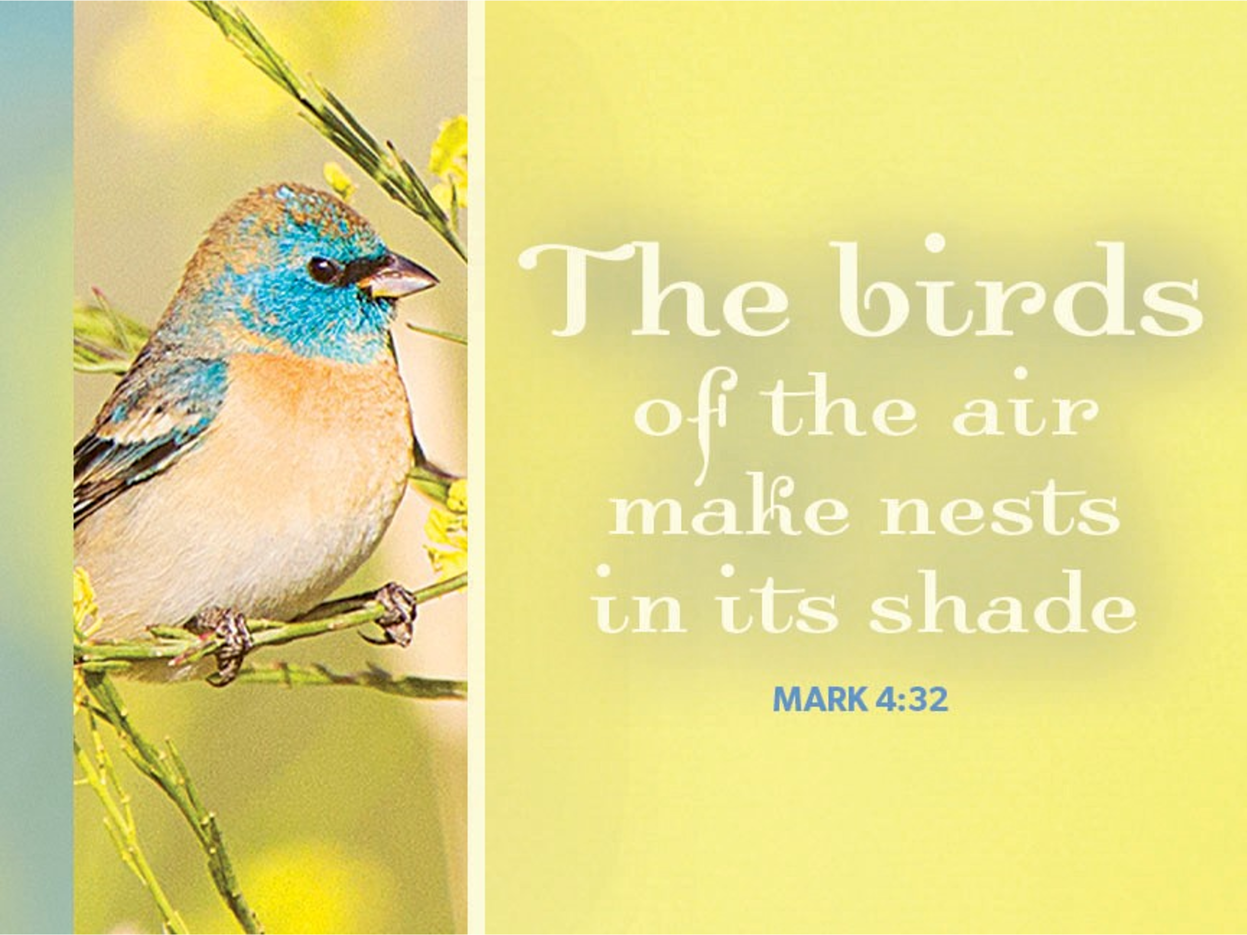

+ Proclaim Christ + Build Community +
+ Serve Our Neighbors +
Introduction
The mustard seed becomes a great shrub that shelters the birds, recalling ancient images of the tree of life. We’d expect a cedar or a sequoia, but Jesus finds the power of God better imaged in a tiny, no-account seed. It’s not the way we expect divine activity to look. Yet the tree of life is here, in the cross around which we gather, the tree into which we are grafted through baptism, the true vine that nourishes us with its fruit in the cup we share. It may not appear all that impressive, but while nobody’s looking it grows with a power beyond our understanding.

An asterisk (*) indicates that we stand for that portion of the service. If standing is difficult, please remain seated. The Congregation responses are in bold print.

Gathering
The Holy Spirit calls us together as the people of God.
Welcome / Announcements / Prelude

*Please stand as you are able.

*Confession and Forgiveness
All may make the sign of the cross, the sign that is marked at baptism, as the presiding minister begins.
Blessed be the holy Trinity, ☩ one God,
the God of manna,
the God of miracles,
the God of mercy. Amen.

Drawn to Christ and seeking God’s abundance,
let us confess our sin.
Silence is kept for reflection.

God, our provider,
help us.
It is hard to believe there is enough to share.
We question your ways when they differ from the ways
of the world in which we live.
We turn to our own understanding
rather than trusting in you.
We take offense at your teachings and your ways.
Turn us again to you.
Where else can we turn?
Share with us the words of eternal life
and feed us for life in the world.
Amen.

Beloved people of God:
in Jesus, the manna from heaven,
you are fed and nourished.
By Jesus, the worker of miracles,
there is always more than enough.
Through Jesus, ☩ the bread of life,
you are shown God’s mercy:
you are forgiven and loved into abundant life. Amen.

*Entrance Hymn ELW #781 Children of the Heavenly Father
sts. 1,3,4

*Greeting
The grace of our Lord Jesus Christ, the love of God, and the communion of the Holy Spirit be with you all. And also with you.

*Hymn of Praise p. 204 Come, Let Us Join
st. 1,4

*Prayer of the Day
O God, you are the tree of life, offering shelter to all the world. Graft us into yourself and nurture our growth, that we may bear your truth and love to those in need, through Jesus Christ, our Savior and Lord. Amen. Be seated.

Word
God speaks to us in scripture reading.

First Lesson Ezekiel 17:22-24
Tree imagery is used in a messianic prophecy to tell how the Lord will choose someone from Judah’s royal family (the cedar tree) to reign over all creation. This tree will be planted on Mount Zion, the location of the holy temple.

²²Thus says the Lord God: I myself will take a sprig from the lofty top of a cedar; I will set it out. I will break off a tender one from the topmost of its young twigs; I myself will plant it on a high and lofty mountain. ²³On the mountain height of Israel I will plant it, in order that it may produce boughs and bear fruit, and become a noble cedar. Under it every kind of bird will live; in the shade of its branches will nest winged creatures of every kind. ²⁴All the trees of the field shall know that I am the Lord. I bring low the high tree, I make high the low tree; I dry up the green tree and make the dry tree flourish. I the Lord have spoken; I will accomplish it.

Word of God, Word of Life. Thanks be to God.

Second Lesson 2 Corinthians 5:6-17
Paul encourages believers to live by faith and not by sight. We do not consider Jesus from a human perspective but through the eyes of faith, believing he died for all and was raised. All who are in Christ are now in God’s new creation.

⁶So we are always confident; even though we know that while we are at home in the body we are away from the Lord—⁷for we walk by faith, not by sight. ⁸Yes, we do have confidence, and we would rather be away from the body and at home with the Lord. ⁹So whether we are at home or away, we make it our aim to please him. ¹⁰For all of us must appear before the judgment seat of Christ, so that each may receive recompense for what has been done in the body, whether good or evil.
[¹¹Therefore, knowing the fear of the Lord, we try to persuade others; but we ourselves are well known to God, and I hope that we are also well known to your consciences. ¹²We are not commending ourselves to you again, but giving you an opportunity to boast about us, so that you may be able to answer those who boast in outward appearance and not in the heart. ¹³For if we are beside ourselves, it is for God; if we are in our right mind, it is for you. ] ¹⁴For the love of Christ urges us on, because we are convinced that one has died for all; therefore all have died. ¹⁵And he died for all, so that those who live might live no longer for themselves, but for him who died and was raised for them.
¹⁶From now on, therefore, we regard no one from a human point of view; even though we once knew Christ from a human point of view, we know him no longer in that way. ¹⁷So if anyone is in Christ, there is a new creation: everything old has passed away; see, everything has become new!

Word of God, Word of Life. Thanks be to God.

*Please stand as you are able.
*Gospel Acclamation p. 205 Alleluia!
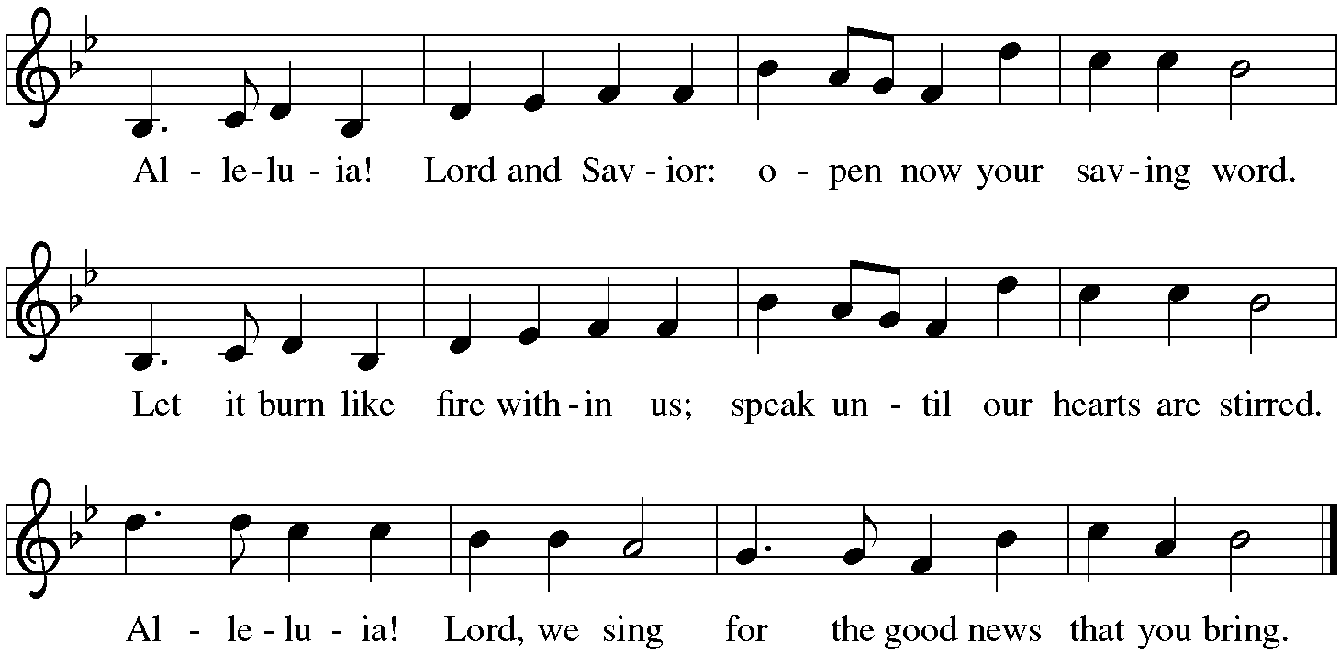

The holy Gospel according to Mark. Glory to you, O Lord.
*Gospel Mark 4:26-34
Jesus frequently uses parables to teach ordinary people as they are able to hear and understand. Images of sowing and growing show the vitality of God’s kingdom.

²⁶[Jesus] said, “The kingdom of God is as if someone would scatter seed on the ground,²⁷and would sleep and rise night and day, and the seed would sprout and grow, he does not know how. ²⁸The earth produces of itself, first the stalk, then the head, then the full grain in the head. ²⁹But when the grain is ripe, at once he goes in with his sickle, because the harvest has come.”
³⁰He also said, “With what can we compare the kingdom of God, or what parable will we use for it? ³¹It is like a mustard seed, which, when sown upon the ground, is the smallest of all the seeds on earth; ³²yet when it is sown it grows up and becomes the greatest of all shrubs, and puts forth large branches, so that the birds of the air can make nests in its shade.”
³³With many such parables he spoke the word to them, as they were able to hear it; ³⁴he did not speak to them except in parables, but he explained everything in private to his disciples.

The Gospel of the Lord. Praise to you, O Christ. Be seated.

The Sermon The Rev. Jeffrey Koth

*Please stand as you are able.
*Hymn of the Day ELW #551 The Spirit Sends Us Forth to Serve
sts. 1,3,4

*Apostles’ Creed

With the whole church, let us confess our faith.
I believe in God, the Father almighty, creator of heaven and earth. I believe in Jesus Christ, God's only Son, our Lord, who was conceived by the Holy Spirit, born of the virgin Mary, suffered under Pontius Pilate, was crucified, died, and was buried; he descended to the dead. On the third day he rose again; he ascended into heaven, he is seated at the right hand of the Father, and he will come to judge the living and the dead. I believe in the Holy Spirit, the holy catholic church, the communion of saints, the forgiveness of sins, the resurrection of the body, and the life everlasting. Amen.

*Prayers of Intercession
We come before the triune God to pray for our communities, ourselves, and our world.
A brief silence.

Nourish your faithful people through gifts of word and worship. Guide the church in listening to and interpreting your message of grace for this time and place in history. In your wisdom, lead us in expanding the reach of your love. Merciful God,
receive our prayer.

Nature sings your love in the morning and your faithfulness at night. Sustain the holy rhythms of creation: days and seasons, hibernation and activity, phases of the moon and tides of the sea. Let these patterns assure us of your constancy. Merciful God,
receive our prayer.

You raise the lowly and humble those in high regard. Raise up all who are victims of marginalization, discrimination, and hate. As we anticipate Juneteenth, banish white supremacy and bigotry from the hearts of your people and remove the inclination toward anger and violence. Merciful God,
receive our prayer.

Tend to all who journey by faith and who wait with patience for the fulfillment of your healing promises especially those we name before you now either silently or aloud. . . Grant perseverance to people doing physical and occupational therapy, people living with mobility concerns, and people facing chronic pain. Merciful God,
receive our prayer.

As you have loved us, so let us love one another. Empower fathers, stepfathers, grandfathers, adoptive fathers, and chosen fathers to embody this gift of love for their children. Where these relationships are strained or broken, bring your comfort and peace. Merciful God,
receive our prayer.
Here other intercessions may be offered.

With gratitude, we remember the saints who are now at home with you. Plant seeds of their wisdom and witness in our hearts, that we grow in faith until we join them in your heavenly dwelling. Merciful God,
receive our prayer.

Receive our prayers, O God, and come quickly to our aid, through the power of the Spirit and the love of Jesus Christ.
Amen.

*Peace
The peace of Christ be with you always. And also with you.
Please share the peace with others in your household, or by making a sign of peace to those on Zoom. You may then be seated as the table is prepared.

Gathering of Gifts
We gather gifts for those in need and for the church’s mission.

Music During Offering

*Please stand as you are able. The gifts are brought forward while the congregation sings:
*Offertory Response ELW #184 Let the Vineyards Be Fruitful

Meal
God feeds us with the presence of Jesus Christ.
*Offering Prayer
Jesus, Bread of life,
you have set this table with your very self,
and called us to the feast of plenty.
Gather what has been sown among us,
and strengthen us in this meal.
Make us to be what we receive here,
your body for the life of the world.
Amen.

*Great Thanksgiving
The Lord be with you. And also with you.
Lift up your hearts. We lift them to the lord.
Let us give thanks to the Lord our God. It is right to give our thanks and praise.

*Preface
It is indeed right, our duty and our joy,
that we should at all times and in all places give thanks and praise to you,
almighty and merciful God, through our Savior Jesus Christ;
who on this day overcame death and the grave,
and by his glorious resurrection opened to us the way of everlasting life.
And so, with all the choirs of angels,
with the church on earth and the hosts of heaven,
we praise your name and join their unending hymn:

*Sanctus p. 207 Holy, Holy, Holy

*Thanksgiving at the Table
We give you thanks, Father, through Jesus Christ, your beloved Son,
whom you sent in this end of the ages
to save and redeem us and to proclaim to us your will.
He is your Word, inseparable from you,
through whom you created all things, and in whom you take delight.
He is your Word, sent from heaven to a virgin’s womb.
He there took on our nature and our lot and was shown forth as your Son,
born of the Holy Spirit and of the virgin Mary.
He, our Lord Jesus, fulfilled all your will and won for you a holy people;
he stretched out his hands in suffering
in order to free from suffering those who trust you.
He is the one who, handed over to a death he freely accepted,
in order to destroy death, to break the bonds of the evil one,
to crush hell underfoot, to give light to the righteous,
to establish his covenant, and to show forth the resurrection,
taking bread and giving thanks to you, said:

Take and eat; this is my body, given for you. Do this for the remembrance of me.

In the same way he took the cup, gave thanks, and gave it for all to drink, saying:

This cup is the new covenant in my blood, shed for you and for all people for the forgiveness of sin. Do this for the remembrance of me.

Remembering, then, his death and resurrection,
we take this bread and cup, living you thanks that you have made us worthy
to stand before you and to serve you as your priestly people.
Send your Spirit upon these gifts of your church;
gather into one all who share this bread and wine;
fill us with your Holy Spirit to establish our faith in truth,
that we may praise and glorify you through your Son Jesus Christ;
through whom all glory and honor are yours, almighty Father,
with the Holy Spirit, in your holy church, both now and forever.
Amen.

*The Lord’s Prayer
Gathered into one by the Holy Spirit, let us pray as Jesus taught us.
Our Father, who art in heaven, hallowed be thy name, thy kingdom come, thy will be done on earth as it is in heaven. Give us this day our daily bread; and forgive us our trespasses, as we forgive those who trespass against us; and lead us not into temptation, but deliver us from evil. For thine is the kingdom, and the power, and the glory, forever and ever. Amen.

*Invitation to Communion
Christ has set the table with more than enough for all. Come! Be seated.

Communion
Those who wish to come for communion may do so at the ushers’ direction. You may return to your seat by the side aisles after you have received the bread and wine.

For those receiving communion from home:
This is the body of Christ, given for you. Amen (Eat the bread.)
This is the blood of Christ, shed for you. Amen (Drink the juice.)

Agnus Dei p. 208 Lamb of God

Music during Communion

*Please stand as you are able.
*Post Communion Blessing
May the body and blood of our Lord Jesus Christ strengthen you and keep you in his grace. Amen.

*Post Communion Prayer
Jesus, Bread of life,
we have received from your table
more than we could ever ask.
As you have nourished us in this meal,
now strengthen us to love the world with your own life.
In your name we pray.
Amen.

Sending
God blesses us and sends us in mission to the world.
*Blessing
The blessing of God,
who provides for us, feeds us, and journeys with us,
☩ be upon you now and forever.
Amen.

*Sending Hymn ELW #671 Shine, Jesus, Shine
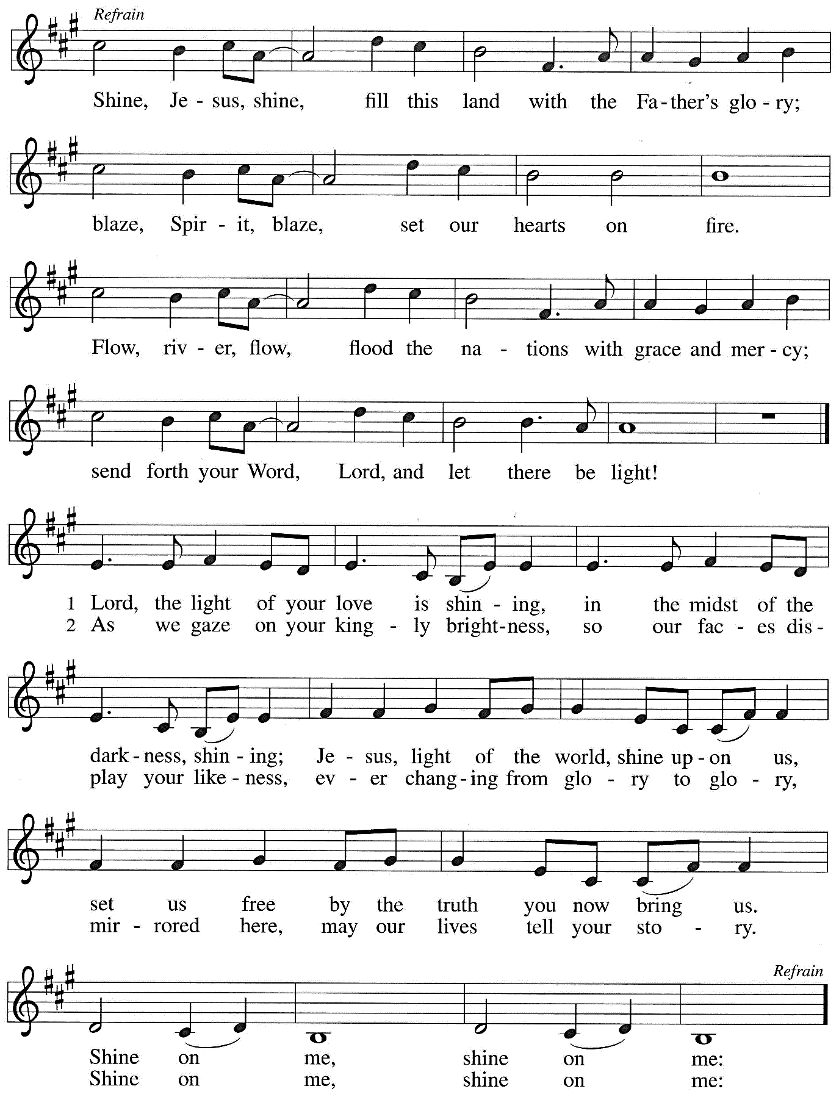
*Sent to the World
Go in peace. You are the body of Christ.
Thanks be to God.

Postlude

From Sundays and Seasons v.20190109.1233 Copyright © 2024 Augsburg Fortress. All rights reserved.
Reprinted by permission under Augsburg Fortress Liturgies Annual License #30867.
All rights reserved. Reprinted under OneLicense.net #A-718333.

Assisting in Worship Today
Worship Leader Rev. Jeffrey Koth
Pianist Sandra Venturoni
Altar Care Cheryl Huizenga
Lector Jason Graf
Ushers Jacky Andersen, Jeff Nelson
Zoom Mark Hamilton, Jon & Cathy Milleville
Fellowship Hour Andy Swiston
Altar Flowers Jerry & Brigitte Miller for God’s many blessings
and Heidi Bolanos in honor of Chuck & Jan Miller’s 62nd Anniversary

Remember in Prayer
Jake Jacobson, Member, Healing & Strength
George LaRocco, brother-in-law of Jean Derrico, Healing & Strength
Erik Sudds, Member, Healing & Strength

Announcements
Wanted-LED Screens 50” or Larger: We would like to update several of the LED’s we have at Grace to bring in newer technology and better picture. If you have one you would like to donate to Grace, please contact Mark Hamilton at 630-841-2941 or marham999@gmail.com. Mark will even come and pick it up from you! Thank you.

Rapid Response to Migrant Bus Arrivals: As you may have heard, buses are pulling up almost daily at the Glen Ellyn Metra station, dropping off migrants on their way to Chicago. Several local churches are sending volunteers to greet them and offer basic supplies to support them on the next leg of their journey.
The Sharing Circle is supporting this effort. We are asking for donations to fill bags with water, granola bars, toiletries, wipes, diapers etc. To support our efforts, you can place donations of needed items in our bin in the narthex. This could be an ongoing need throughout the summer.
The following items are needed the most: Bottled water; granola bars; fruit snacks; diapers (sizes 3,4,5); wipes; toiletries (toothpaste, toothbrush, tissues, deodorant, Band-Aids, shampoo & conditioner, bar soap, panty liners).
If you would like to participate in a packing session, please let Karin know and she will contact you when one is scheduled. slenczka.k@gmail.com or 202-352-0657

Call Committee Corner: The next step for the Call Committee is to complete the Ministry Site Profile (MSP). To do this, we would like to hear from you. We have sent out an electronic survey to help us develop a profile that wholly represents our congregation.
We welcome all members of your family to participate in the survey. However, only one survey will be allowed to be completed per device. To access the survey online, click on this link: Grace Luther Survey Online.

The Call Committee will hold two more forums on Sunday, 6/16 and 6/23 before worship (from 9-10 am) to answer your questions about the Call Process. During the forums, Committee Members will be available to assist with completing the online survey. Paper copies will also be made available.
Your opinion is essential in developing an MSP that accurately reflects Grace. Please join us in the Call Process by completing your survey, and let’s work together to find our next Pastor.
Glen House Food Pantry: June is Grace's month for food donations to the GEFP now GHFP. Glen Ellyn has been changed to Glen House. Bins are in the narthex to accept your donations.

People of Grace: We have the June dinner set for Tuesday, June 18th at 7 PM at Reserve 22. Please RSVP to Jeff Nelson if you are planning to attend. jeff.nelson@vlses.com

CROPWalk: Who would be interested in being Grace’s coordinator next year? There are three evening meetings and Crop Walk Sunday, May 3, 2025. It’s easy and it’s fun to meet other church reps. Please let me know so I can give your name and contact information to the organizers for 2025. Thank you. Doris Nelson 630-346-9377 or dorisnelson433@icloud.com

Every Member a Minister and Missionary!

Phone: 630-469-1555 Emergency Pastoral Contact: 224-355-4213
info@graceglenellyn.org www.graceglenellyn.org

Interim Pastor
Rev. Jeffrey Koth office ext. 14
revjkoth@gmail.com

