Grace Lutheran Church

493 Forest Avenue, Glen Ellyn IL 630.469.1555
www.graceglenellyn.org

7th Sunday after Pentecost July 7, 2024

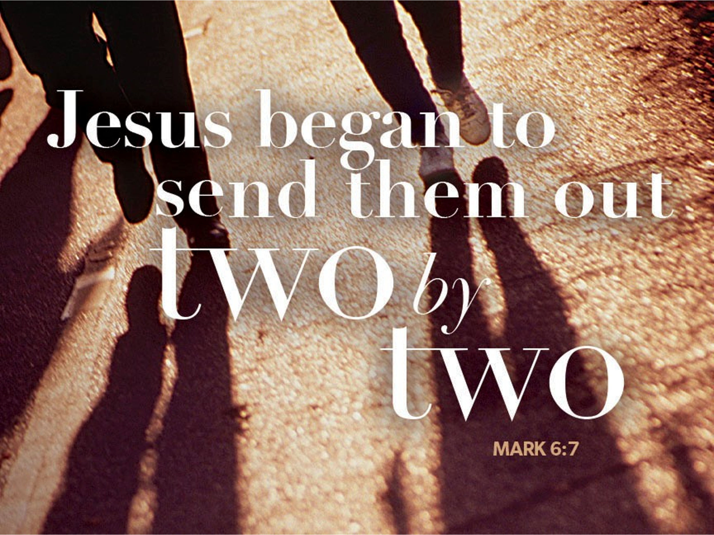

+ Proclaim Christ + Build Community +
+ Serve Our Neighbors +

Introduction
Jesus does great deeds of power and gives his disciples authority over demons. Yet none of this power is unilateral; it all must be received by faith. Jesus asks his disciples to go out without money or supplies, so that they will be dependent on how others receive them. When we are sent from the assembly to witness and to heal, we are asked to be vulnerable, to be dependent on the reception of others. The Spirit always operates in the “between”: between Jesus and his Abba, between Jesus andus, between you and me, between us and those to whom we are sent.

An asterisk (*) indicates that we stand for that portion of the service. If standing is difficult, please remain seated. The Congregation responses are in bold print.

Gathering
The Holy Spirit calls us together as the people of God.
Welcome / Announcements / Prelude

*Please stand as you are able.

*Confession and Forgiveness
All may make the sign of the cross, the sign that is marked at baptism, as the presiding minister begins.
Blessed be the holy Trinity, ☩ one God,
the God of manna,
the God of miracles,
the God of mercy. Amen.

Drawn to Christ and seeking God’s abundance,
let us confess our sin.
Silence is kept for reflection.

God, our provider,
help us.
It is hard to believe there is enough to share.
We question your ways when they differ from the ways
of the world in which we live.
We turn to our own understanding
rather than trusting in you.
We take offense at your teachings and your ways.
Turn us again to you.
Where else can we turn?
Share with us the words of eternal life
and feed us for life in the world.Amen.

Beloved people of God:
in Jesus, the manna from heaven,
you are fed and nourished.
By Jesus, the worker of miracles,
there is always more than enough.
Through Jesus, ☩ the bread of life,
you are shown God’s mercy:
you are forgiven and loved into abundant life.
Amen.

*Entrance Hymn ELW #813 Faith of Our Fathers, sts. 1,2, 4
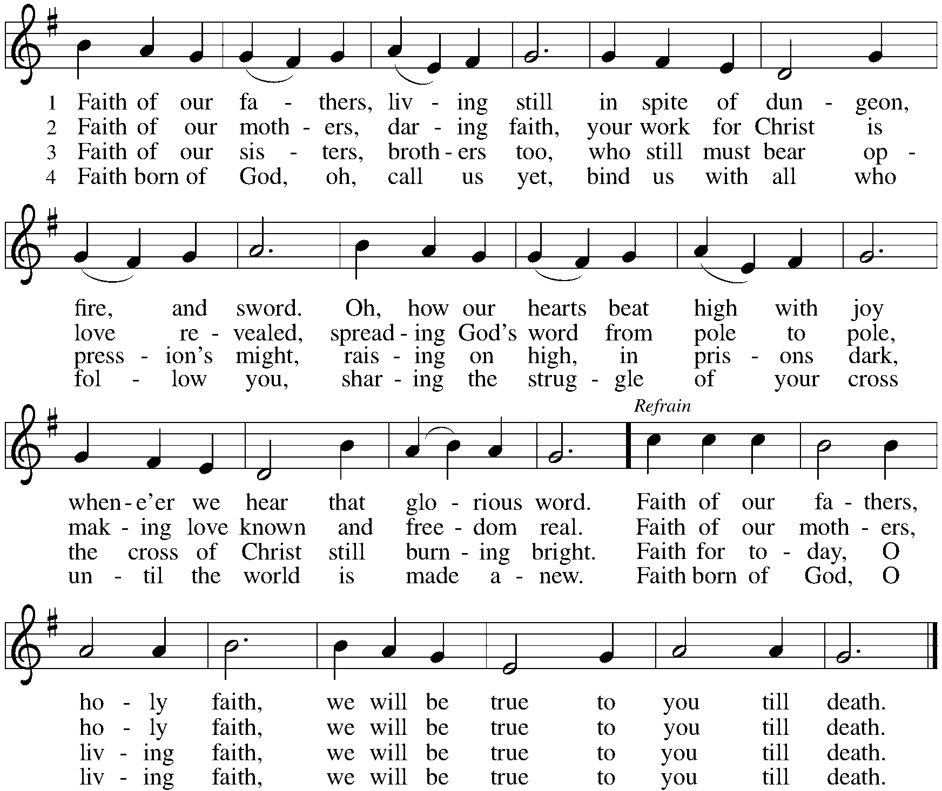

*Greeting
The grace of our Lord Jesus Christ, the love of God, and the communion of the Holy Spirit be with you all. And also with you.

*Hymn of Praise p. 204 Come, Let Us Join, st. 1,4

*Prayer of the Day
God of the covenant, in our baptism you call us to proclaim the coming of your kingdom. Give us the courage you gave the apostles, that we may faithfully witness to your love and peace in every circumstance of life, in the name of Jesus Christ, our Savior and Lord. Amen. Be seated.

Word
God speaks to us in scripture reading.

First Lesson Ezekiel 2:1-5
In 597 BCE, the priest Ezekiel was removed into exile in Babylon. While there, he received a vision of God appearing majestically on a chariot throne. Today’s reading recounts God’s commissioning of Ezekiel during this vision. The prophet is to speak God’s word to a people unwilling to hear.

¹[A voice] said to me: O mortal, stand up on your feet, and I will speak with you.²And when he spoke to me, a spirit entered into me and set me on my feet; and I heard him speaking to me. ³He said to me, Mortal, I am sending you to the people of Israel, to a nation of rebels who have rebelled against me; they and their ancestors have transgressed against me to this very day. ⁴The descendants are impudent and stubborn. I am sending you to them, and you shall say to them, “Thus says the Lord God.” ⁵Whether they hear or refuse to hear (for they are a rebellious house), they shall know that there has been a prophet among them.

Word of God, Word of Life. Thanks be to God.

Second Lesson 2 Corinthians 12:2-10
Christians do not boast of their own accomplishments. Rather, Christian boasting focuses attention on how the power of Christ is present in our lives, especially in times of weakness and vulnerability. No matter what our circumstances in life, Christ’s grace is sufficient for us.

²I know a person in Christ who fourteen years ago was caught up to the third heaven—whether in the body or out of the body I do not know; God knows. ³And I know that such a person—whether in the body or out of the body I do not know; God knows—⁴was caught up into Paradise and heard things that are not to be told, that no mortal is permitted to repeat. ⁵On behalf of such a one I will boast, but on my own behalf I will not boast, except of my weaknesses. ⁶But if I wish to boast, I will not be a fool, for I will be speaking the truth. But I refrain from it, so that no one may think better of me than what is seen in me or heard from me, ⁷even considering the exceptional character of the revelations. Therefore, to keep me from being too elated, a thorn was given me in the flesh, a messenger of Satan to torment me, to keep me from being too elated. ⁸Three times I appealed to the Lord about this, that it would leave me, ⁹but he said to me, “My grace is sufficient for you, for power is made perfect in weakness.” So, I will boast all the more gladly of my weaknesses, so that the power of Christ may dwell in me. ¹⁰Therefore I am content with weaknesses, insults, hardships, persecutions, and calamities for the sake of Christ; for whenever I am weak, then I am strong.

Word of God, Word of Life. Thanks be to God.

*Please stand as you are able.
*Gospel Acclamation p. 205 Alleluia!
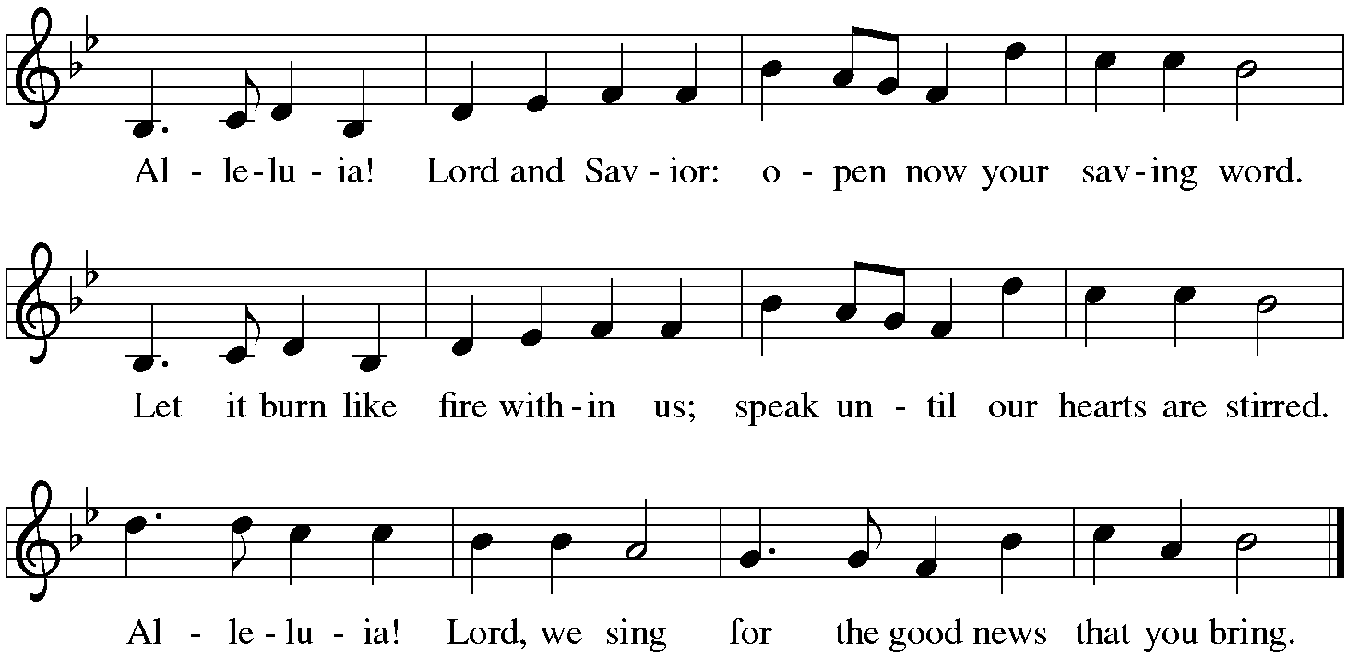

The holy Gospel according to Mark. Glory to you, O Lord.
*Gospel Mark 6:1-13
At home and abroad, Jesus and his disciples encounter resistance as they seek to proclaim God’s word and relieve affliction.

¹[Jesus] came to his hometown, and his disciples followed him.²On the sabbath he began to teach in the synagogue, and many who heard him were astounded. They said, “Where did this man get all this? What is this wisdom that has been given to him? What deeds of power are being done by his hands! ³Is not this the carpenter, the son of Mary and brother of James and Joses and Judas and Simon, and are not his sisters here with us?” And they took offense at him. ⁴Then Jesus said to them, “Prophets are not without honor, except in their hometown, and among their own kin, and in their own house.” ⁵And he could do no deed of power there, except that he laid his hands on a few sick people and cured them. ⁶And he was amazed at their unbelief.
Then he went about among the villages teaching. ⁷He called the twelve and began to send them out two by two, and gave them authority over the unclean spirits. ⁸He ordered them to take nothing for their journey except a staff; no bread, no bag, no money in their belts; ⁹but to wear sandals and not to put on two tunics. ¹⁰He said to them, “Wherever you enter a house, stay there until you leave the place. ¹¹If any place will not welcome you and they refuse to hear you, as you leave, shake off the dust that is on your feet as a testimony against them.” ¹²So they went out and proclaimed that all should repent. ¹³They cast out many demons, and anointed with oil many who were sick and cured them.

The Gospel of the Lord. Praise to you, O Christ. Be seated.

The Sermon The Rev. Jeffrey Koth

*Please stand as you are able.
*Hymn of the Day ELW #887 This Is My Song
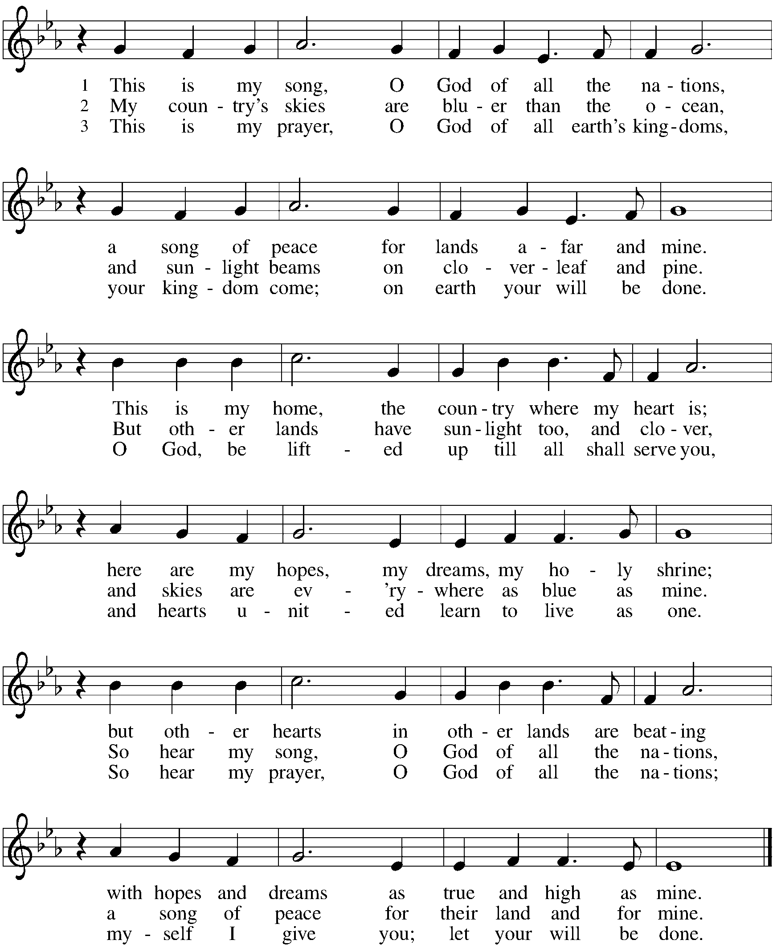

*Apostles’ Creed

With the whole church, let us confess our faith.
I believe in God, the Father almighty, creator of heaven and earth. I believe in Jesus Christ, God's only Son, our Lord, who was conceived by the Holy Spirit, born of the virgin Mary, suffered under Pontius Pilate, was crucified, died, and was buried; he descended to the dead. On the third day he rose again; he ascended into heaven, he is seated at the right hand of the Father, and he will come to judge the living and the dead. I believe in the Holy Spirit, the holy catholic church, the communion of saints, the forgiveness of sins, the resurrection of the body, and the life everlasting. Amen.

*Prayers of Intercession
One in the communion of saints and in the power of the Holy Spirit, we join our voices in prayer.
A brief silence.

Glorious God, you bend down to wash the feet of your disciples. Let the servant church arise in our teaching, our praying, our healing, and our doing. Make all your faithful people powerful in weakness and strong in grace. In your mercy, hear our prayer.

Life-giving God, your fingers trace the heavens and your hands mold the earth. Where there is drought, bring nourishing rain. Where there is devastation from fire or flood, bring relief. Sustain the well-being of every living thing. In your mercy, hear our prayer.

Merciful God, you speak and the nations listen. Open those who govern to the cries of all who journey with no food or shelter, particularly people fleeing violence, those seeking freedom, and those in search of community. In your mercy, hear our prayer.

Gracious God, your embrace brings wholeness to those who are troubled. Anoint all who suffer in any way with the oil of healing and grant them renewal. In your mercy, hear our prayer.

Welcoming God, in your presence strangers become companions and enemies become neighbors. Open our doors to those we have so easily shut out, particularly people who are different from us or who are marginalized by church or society. In your mercy, hear our prayer.
Here other intercessions may be offered.

Eternal God, you gather us into your house of many dwelling places. We give you thanks for our faithful departed. Inspire us by their lives of faith until, with them, we rest forever at our journey’s end. In your mercy, hear our prayer.

Holy God, holy and merciful: into your outstretched arms we commend ourselves and all for whom we pray, trusting in the one who is the way, the truth, and the life, Jesus Christ our Savior and Lord. Amen.

*Peace
The peace of Christ be with you always. And also with you.
Please share the peace with others in your household, or by making a sign of peace to those on Zoom. You may then be seated as the table is prepared.

Gathering of Gifts
We gather gifts for those in need and for the church’s mission.

Music During Offering

*Please stand as you are able. The gifts are brought forward while the congregation sings:
*Offertory Response ELW #184 Let the Vineyards Be Fruitful

Meal
God feeds us with the presence of Jesus Christ.
*Offering Prayer
Jesus, Bread of life,
you have set this table with your very self,
and called us to the feast of plenty.
Gather what has been sown among us,
and strengthen us in this meal.
Make us to be what we receive here,
your body for the life of the world.Amen.

*Great Thanksgiving
The Lord be with you. And also with you.
Lift up your hearts. We lift them to the lord.
Let us give thanks to the Lord our God. It is right to give our thanks and praise.

*Preface
It is indeed right, our duty and our joy,
that we should at all times and in all places
give thanks and praise to you, almighty and merciful God,
through our Savior Jesus Christ: our Good Samaritan, who tends the wounds of body and spirit with the oil of consolation and the wine of hope;
the Sun of righteousness, who raises us to life on his healing wings.
And so, with all the choirs of angels, with the church on earth and the hosts of heaven, we praise your name and join their unending hymn:

*Sanctus p. 207 Holy, Holy, Holy

*Thanksgiving at the Table
In the night in which he was betrayed,
our Lord Jesus took bread, and gave thanks;
broke it, and gave it to his disciples, saying:
Take and eat; this is my body, given for you.
Do this for the remembrance of me.
Again, after supper, he took the cup, gave thanks,
and gave it for all to drink, saying:
This cup is the new covenant in my blood,
shed for you and for all people for the forgiveness of sin.
Do this for the remembrance of me.
*The Lord’s Prayer
Gathered into one by the Holy Spirit, let us pray as Jesus taught us.
Our Father, who art in heaven, hallowed be thy name, thy kingdom come, thy will be done on earth as it is in heaven. Give us this day our daily bread; and forgive us our trespasses, as we forgive those who trespass against us; and lead us not into temptation, but deliver us from evil. For thine is the kingdom, and the power, and the glory, forever and ever. Amen.

*Invitation to Communion
Christ has set the table with more than enough for all. Come! Be seated.

Communion
Those who wish to come for communion may do so at the ushers’ direction. You may return to your seat by the side aisles after you have received the bread and wine.

For those receiving communion from home:
This is the body of Christ, given for you. Amen (Eat the bread.)
This is the blood of Christ, shed for you. Amen (Drink the juice.)

Agnus Dei p. 208 Lamb of God

Music during Communion

*Please stand as you are able.
*Post Communion Blessing
May the body and blood of our Lord Jesus Christ strengthen you and keep you in his grace. Amen.

*Post Communion Prayer
Jesus, Bread of life,
we have received from your table
more than we could ever ask.
As you have nourished us in this meal,
now strengthen us to love the world with your own life.
In your name we pray. Amen.

Sending
God blesses us and sends us in mission to the world.
*Blessing
The blessing of God,
who provides for us, feeds us, and journeys with us,
☩ be upon you now and forever. Amen.

*Sending Hymn ELW #891 God Bless Our Native Land
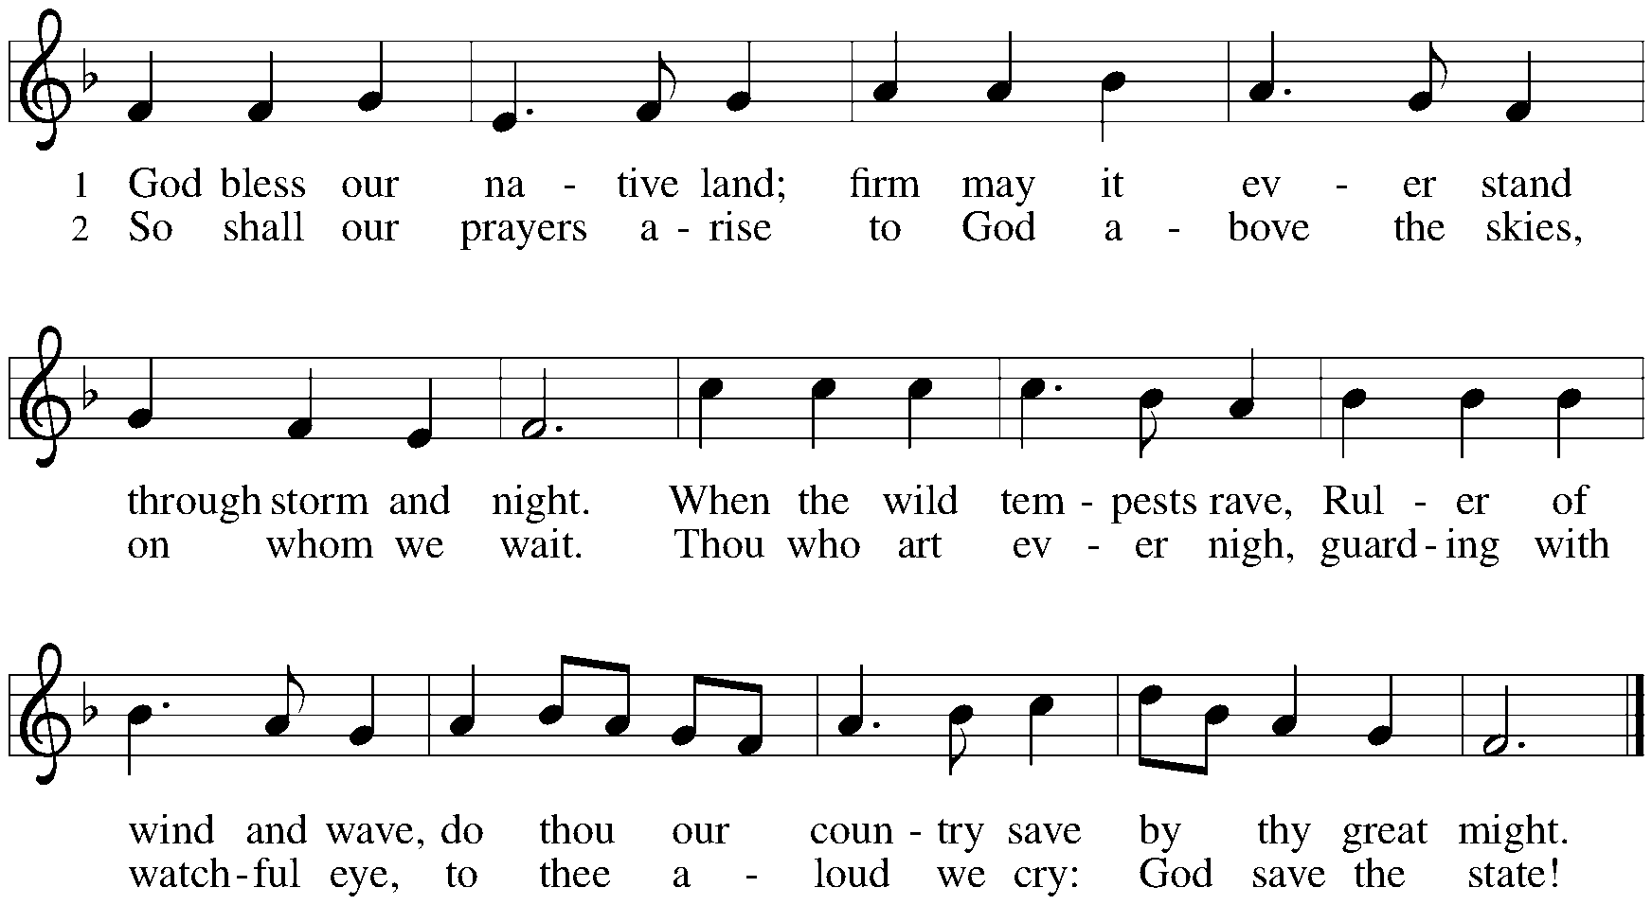
*Sent to the World
Go in peace. Share the Good News. Thanks be to God.

Postlude

From Sundays and Seasons v.20190109.1233 Copyright © 2024 Augsburg Fortress. All rights reserved.
Reprinted by permission under Augsburg Fortress Liturgies Annual License #30867.
All rights reserved. Reprinted under OneLicense.net #A-718333.

Assisting in Worship Today
Worship Leader Rev. Jeffrey Koth
Pianist Sandra Venturoni
Altar Care Cheryl Huizenga
Lector Heather Graf
Ushers
Zoom Mark Hamilton, Jon & Cathy Milleville
Fellowship Hour Andy Swiston

Remember in Prayer
Jake Jacobson, Member, Healing & Strength
George LaRocco, brother-in-law of Jean Derrico, Healing & Strength
Erik Sudds, Member, Healing & Strength

Announcements
FaithTalk: Due to the July 4th Holiday, FaithTalk will meet this Thursday, July 11 at 12:30pm. Stay after to blood if you are able!

Music Director Search: While we are not actively conducting a search at this time, there may be a candidate you hear about whose information you want to share with Grace. Jim Kregor will be the point of contact for these inquiries. Jim’s contact information is jpkregor@juno.com.

Pr. Jeff’s Contact Information: revjkoth@gmail.com or 224-355-4213. Just a reminder that his information is available on Grace’s website, in Grace To You, and on the back of the worship bulletin.

FYI: The church office will be closed through Friday, July 12. Insert pages for GTY are due at the church office by Sunday, July 14. Thank you.

Christ in Our Home and The Word in Season: The July/August/September issues are in the Narthex on the slatwall.

Library: We have a small library in the Activity Room if you would like a book to read or donate.

Introducing Grace Connects: The Grace Connects task force is seeking volunteers to host activities on the 2nd Thursday and 4th Sunday of the month. With these programs, we are reaching out to engage members of our congregation, as well as our neighbors living in surrounding apartment/condo buildings and the Village of Glen Ellyn. All are invited to participate!

Do you have a talent to share, a program you've always dreamed of hosting? Join us after worship on a Sunday in July (7/14, 7/21, 7/28) to learn more about the Grace Connects program and volunteer to host an activity. Updates about scheduled activities (starting in August) will be advertised in the Grace to You monthly newsletter, the weekly bulletin, and the At Your Service Senior Center newsletter.

Senior Center Newsletter: The At Your Service Senior Center newsletter published by the Village of Glen Ellyn is available electronically at www.glenellyn.org/169/Senior-Center.

Blood Drive: Thursday, July 11, 2:30-7pm. Donate and be entered to win a grill! All attempting donors will be entered for a chance to win one grill including accessories. Make your appointment at www.versiti.org/IL, or call 800-7to-give, or scan the QR code.

Wanted-LED Screens 50” or Larger: We would like to update several of the LED’s we have at Grace to bring in newer technology and better pictures. If you have one you would like to donate to Grace, please contact Mark Hamilton at 630-841-2941 or marham999@gmail.com. Mark will even come and pick it up from you! Thank you.

Rapid Response to Migrant Bus Arrivals: As you may have heard, buses are pulling up almost daily at the Glen Ellyn Metra station, dropping off migrants on their way to Chicago. Several local churches are sending volunteers to greet them and offer basic supplies to support them on the next leg of their journey.
The Sharing Circle is supporting this effort. We are asking for donations to fill bags with water, granola bars, toiletries, wipes, diapers etc. To support our efforts, you can place donations of needed items in our bin in the narthex. This could be an ongoing need throughout the summer.
The following items are needed the most: Bottled water; granola bars; fruit snacks; diapers (sizes 3,4,5); wipes; toiletries (toothpaste, toothbrush, tissues, deodorant, Band-Aids, shampoo & conditioner, bar soap, panty liners).
If you would like to participate in a packing session, please let Karin know and she will contact you when one is scheduled. slenczka.k@gmail.com or 202-352-0657

Zoom Worship: We offer a Zoom link for our 10am Sunday worship service for those who are continuing to participate from home. If you need a bulletin, remember you can view (on another device) or download/print a bulletin from Grace's website. Just click on Quick Link to Worship.
Zoom link: https://us02web.zoom.us/j/89031586315
Dial In: 1-312-626-6799 Meeting ID: 890 3158 6315

Volunteers Needed: The newly formed Grace Connects committee is charged with organizing and creating a senior ministry here at Grace with activities to meet our mission of senior outreach to our Grace members and the local community.
Committee members are Sue Davison, Susi Nelson, Susan Jacobson, Cathy Milleville, Paul Rom. If you are interested in helping or would like more information, please contact a committee member or the church office.
Volunteering can be as simple as serving refreshments or baking for an event. Or perhaps you have an idea, talent, or activity you would like to share at one of our gatherings. Or maybe you have an idea of what we could possibly offer.

Game Day Hosts! Hello Grace members. As we expand our connections and outreach to our seniors at Grace and in our neighborhood, we are proposing two 'Games Days' each month in the Fellowship Room at Grace. We are looking for volunteer hosts who would be willing to help host the event and serve light refreshments to the group and either lead their own game of choice or organize one that is provided for them. Possible game ideas are bingo, bunko, chess/checkers, and board or card games. Please contact Cathy Milleville or Susi Nelson if you are interested in helping with this outreach ministry.

Be a Welcome Minister! The table in the back of the sanctuary has a Visitor Sign-In Sheet and a blue gift bag with a Grace coffee mug. When you are talking with a visitor, please direct them to the table to obtain their information and present them with a blue gift bag. Thank you.
Donate and Make a Difference: Consider making a tax-deductible contribution to Grace Church. Scan this QR code to be directed to our secure online giving page. Your contributions are vital in helping us fulfill our mission!
About Us: Scan this QR code to visit our "About Us" webpage and discover more about our church, beliefs, and ministries.

Historic Game Night - Mystery Games: Friday July 19 – 5pm to 8pm – at the Glen Ellyn History Center, 800 N. Main Street. This event, planned by the Glen Ellyn Historical Society, is for families, friends and the opportunity to make new friends at the Historic Game Night! The evening Includes a brief presentation about the evolution of mystery games given before people are welcome to try several different games at the History Center. Free event - there will be a variety of mystery games available for everyone to play at this event. www.gehs.org - 630-469-1867.

Glen Ellyn Historical Society Presents Chicago’s Sweet Candy History: Saturday, July 13, 2pm. Actress and historian Leslie Goddard presents the sweet story of Chicago’s Candy History. This event is at the Glen Ellyn History Center, 800 N. Main Street. Goddard takes her audience on a “candy trail,” through the candies that were either made or invented in Chicago. Snickers, Milky Way, Wrigley gum, Cracker Jack, Baby Ruth and Butterfinger are all products of this great industry. How can we forget Tootsie Rolls and the very popular Frango Mints? Find out why immigrants played a critical role in confectionery history. Goddard even has prepared a fun “candy quiz.” The entire event is delicious. Adult admission is $10, $8 GEHS members and students. Call 630-469-1867 and check the website at www.gehs.org.

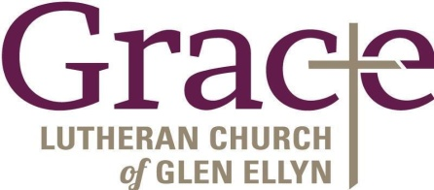

Every Member a Minister and Missionary!

Phone: 630-469-1555 Emergency Pastoral Contact: 224-355-4213
info@graceglenellyn.org www.graceglenellyn.org

Interim Pastor
Rev. Jeffrey Koth office ext. 14
revjkoth@gmail.com

Pianist
Sandra Venturoni 630-469-7614
sventuroni@sbcglobal.net

Children’s Ministry Coordinator
Cyndy Drager 630-659-4922
mmscyndy@aol.com

Office Manager
Barbara Sudds office ext. 10
bsudds@graceglenellyn.org

Parish Counselor
Carole LoGalbo M.S., LCPC 630-668-4594
carolelogalbo@yahoo.com

Custodian
Julian Mendoza

