Grace Lutheran Church

493 Forest Avenue, Glen Ellyn IL 630.469.1555
www.graceglenellyn.org

8th Sunday after Pentecost July 14, 2024

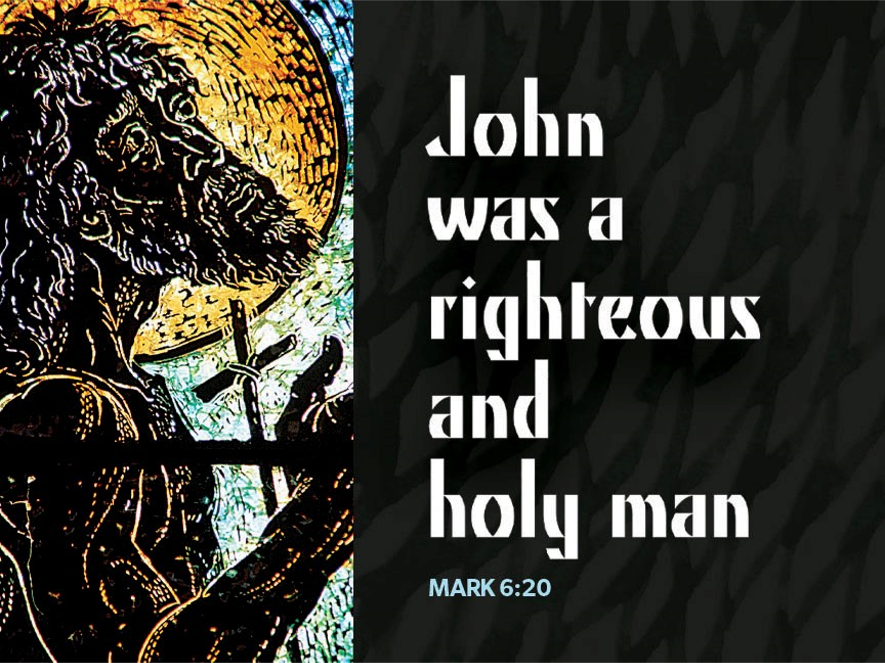

+ Proclaim Christ + Build Community +
+ Serve Our Neighbors +

Introduction
When Amos reports his vision of God judging Israel for its mistreatment of the poor, he becomes a threat to the power of the priests and the king. John the Baptist also speaks truth to power, and Herod has him killed. In Herod’s fear that Jesus is John returned from the dead, we may hear hope for the oppressed: all the prophets killed through the ages are alive in Jesus. We are called to witness to justice in company with them, and to proclaim God’s saving love.

An asterisk (*) indicates that we stand for that portion of the service. If standing is difficult, please remain seated. The Congregation responses are in bold print.

Gathering
The Holy Spirit calls us together as the people of God.
Welcome / Announcements / Prelude

*Please stand as you are able.

*Confession and Forgiveness
All may make the sign of the cross, the sign that is marked at baptism, as the presiding minister begins.
Blessed be the holy Trinity, ☩ one God,
the God of manna,
the God of miracles,
the God of mercy. Amen.

Drawn to Christ and seeking God’s abundance,
let us confess our sin.
Silence is kept for reflection.

God, our provider,
help us.
It is hard to believe there is enough to share.
We question your ways when they differ from the ways
of the world in which we live.
We turn to our own understanding
rather than trusting in you.
We take offense at your teachings and your ways.
Turn us again to you.
Where else can we turn?
Share with us the words of eternal life
and feed us for life in the world. Amen.

Beloved people of God:
in Jesus, the manna from heaven,
you are fed and nourished.
By Jesus, the worker of miracles,
there is always more than enough.
Through Jesus, ☩ the bread of life,
you are shown God’s mercy:
you are forgiven and loved into abundant life.
Amen.

*Entrance Hymn ELW #786 O Holy Spirit Enter In
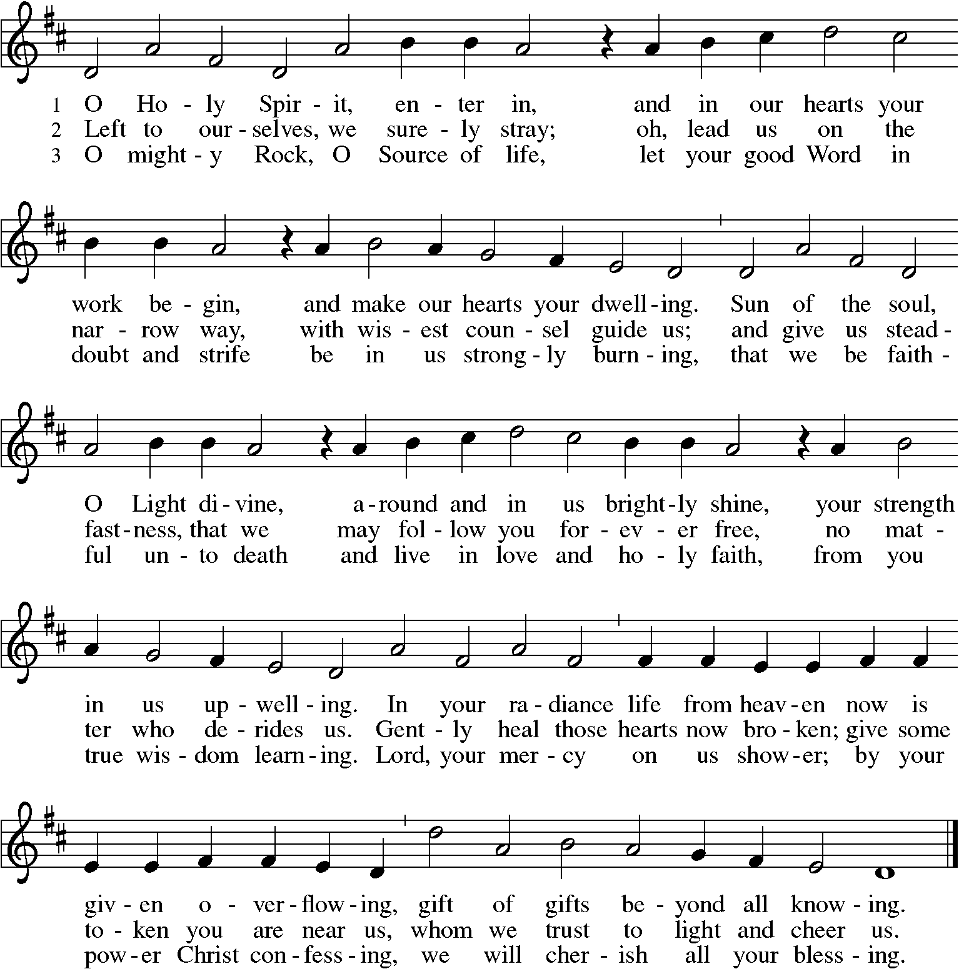

*Greeting
The grace of our Lord Jesus Christ, the love of God, and the communion of the Holy Spirit be with you all. And also with you.

*Hymn of Praise p. 204 Come, Let Us Join, sts. 1,4

*Prayer of the Day
O God, from you come all holy desires, all good counsels, and all just works. Give to us, your servants, that peace which the world cannot give, that our hearts may be set to obey your commandments; and also that we, being defended from the fear of our enemies, may live in peace and quietness, through Jesus Christ, our Savior and Lord. Amen. Be seated.

Word
God speaks to us in scripture reading.

First Lesson Amos 7:7-15
Amos is not the kind of prophet attached to temples or royal courts. Rather, he is an ordinary farmer from Judah (the southern kingdom) called by God to speak to Israel (the northern kingdom). God’s word of judgment through Amos conflicts with the king’s court prophet Amaziah, whom Amos encounters at Bethel.

⁷This is what [the Lord God] showed me: the Lord was standing beside a wall built with a plumb line, with a plumb line in his hand. ⁸And the Lord said to me, “Amos, what do you see?” And I said, “A plumb line.” Then the Lord said,
“See, I am setting a plumb line in the midst of my people Israel; I will never again pass them by; ⁹the high places of Isaac shall be made desolate, and the sanctuaries of Israel shall be laid waste, and I will rise against the house of Jeroboam with the sword.”
¹⁰Then Amaziah, the priest of Bethel, sent to King Jeroboam of Israel, saying, “Amos has conspired against you in the very center of the house of Israel; the land is not able to bear all his words. ¹¹For thus Amos has said, ‘Jeroboam shall die by the sword, and Israel must go into exile away from his land.’ ”
¹²And Amaziah said to Amos, “O seer, go, flee away to the land of Judah, earn your bread there, and prophesy there; ¹³but never again prophesy at Bethel, for it is the king’s sanctuary, and it is a temple of the kingdom.”
¹⁴Then Amos answered Amaziah, “I am no prophet, nor a prophet’s son; but I am a herdsman, and a dresser of sycamore trees, ¹⁵and the Lord took me from following the flock, and the Lord said to me, ‘Go, prophesy to my people Israel.’ ”

Word of God, Word of Life. Thanks be to God.

Second Lesson Ephesians 1:3-14
In Jesus, all of God’s plans and purposes have been made known as heaven and earth are united in Christ. Through Jesus, we have been chosen as God’s children and have been promised eternal salvation.

³Blessed be the God and Father of our Lord Jesus Christ, who has blessed us in Christ with every spiritual blessing in the heavenly places, ⁴just as he chose us in Christ before the foundation of the world to be holy and blameless before him in love. ⁵He destined us for adoption as his children through Jesus Christ, according to the good pleasure of his will, ⁶to the praise of his glorious grace that he freely bestowed on us in the Beloved. ⁷In him we have redemption through his blood, the forgiveness of our trespasses, according to the riches of his grace ⁸that he lavished on us. With all wisdom and insight ⁹he has made known to us the mystery of his will, according to his good pleasure that he set forth in Christ, ¹⁰as a plan for the fullness of time, to gather up all things in him, things in heaven and things on earth. ¹¹In Christ we have also obtained an inheritance, having been destined according to the purpose of him who accomplishes all things according to his counsel and will, ¹²so that we, who were the first to set our hope on Christ, might live for the praise of his glory. ¹³In him you also, when you had heard the word of truth, the gospel of your salvation, and had believed in him, were marked with the seal of the promised Holy Spirit; ¹⁴this is the pledge of our inheritance toward redemption as God’s own people, to the praise of his glory.

Word of God, Word of Life. Thanks be to God.

*Please stand as you are able.
*Gospel Acclamation p. 205 Alleluia!
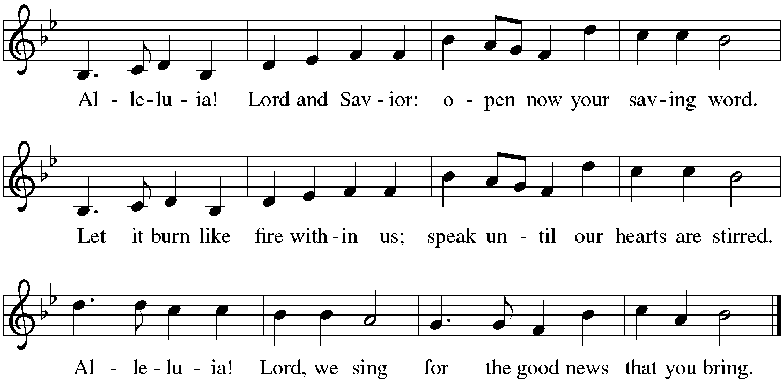

The holy Gospel according to Mark. Glory to you, O Lord.
*Gospel Mark 6:14-29
As Jesus and his disciples begin to attract attention, Mark recalls the story of John the Baptist’s martyrdom. Like John, Jesus and his disciples will also suffer at the hands of those opposed to the gospel of salvation.

¹⁴King Herod heard of [the disciples’ preaching,] for Jesus’ name had become known. Some were saying, “John the baptizer has been raised from the dead; and for this reason these powers are at work in him.” ¹⁵But others said, “It is Elijah.” And others said, “It is a prophet, like one of the prophets of old.” ¹⁶But when Herod heard of it, he said, “John, whom I beheaded, has been raised.”
¹⁷For Herod himself had sent men who arrested John, bound him, and put him in prison on account of Herodias, his brother Philip’s wife, because Herod had married her. ¹⁸For John had been telling Herod, “It is not lawful for you to have your brother’s wife.” ¹⁹And Herodias had a grudge against him, and wanted to kill him. But she could not, ²⁰for Herod feared John, knowing that he was a righteous and holy man, and he protected him. When he heard him, he was greatly perplexed; and yet he liked to listen to him. ²¹But an opportunity came when Herod on his birthday gave a banquet for his courtiers and officers and for the leaders of Galilee. ²²When his daughter Herodias came in and danced, she pleased Herod and his guests; and the king said to the girl, “Ask me for whatever you wish, and I will give it.” ²³And he solemnly swore to her, “Whatever you ask me, I will give you, even half of my kingdom.” ²⁴She went out and said to her mother, “What should I ask for?” She replied, “The head of John the baptizer.” ²⁵Immediately she rushed back to the king and requested, “I want you to give me at once the head of John the Baptist on a platter.” ²⁶The king was deeply grieved; yet out of regard for his oaths and for the guests, he did not want to refuse her. ²⁷Immediately the king sent a soldier of the guard with orders to bring John’s head. He went and beheaded him in the prison, ²⁸brought his head on a platter, and gave it to the girl. Then the girl gave it to her mother. ²⁹When his disciples heard about it, they came and took his body, and laid it in a tomb.

The Gospel of the Lord. Praise to you, O Christ. Be seated.

The Sermon The Rev. Jeffrey Koth

*Please stand as you are able.
*Hymn of the Day ELW #717 Let Justice Flow like Streams
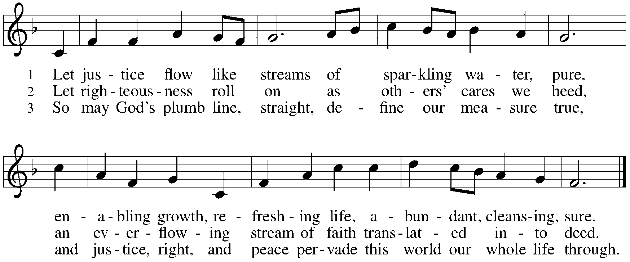

*Apostles’ Creed

With the whole church, let us confess our faith.
I believe in God, the Father almighty, creator of heaven and earth. I believe in Jesus Christ, God's only Son, our Lord, who was conceived by the Holy Spirit, born of the virgin Mary, suffered under Pontius Pilate, was crucified, died, and was buried; he descended to the dead. On the third day he rose again; he ascended into heaven, he is seated at the right hand of the Father, and he will come to judge the living and the dead. I believe in the Holy Spirit, the holy catholic church, the communion of saints, the forgiveness of sins, the resurrection of the body, and the life everlasting. Amen.

*Prayers of Intercession
One in the communion of saints and in the power of the Holy Spirit, we join our voices in prayer.
A brief silence.

You gather your people into the body of Christ. Where your church is wounded, heal it. Where it is right, strengthen it. Where it is divided, reunite it. In your mercy, hear our prayer.

From before the foundation of the world, you are God. Revive ecosystems destroyed by human greed. Curb our desire to put wealth ahead of the health of all who call this planet home. In your mercy, hear our prayer.

You establish equity and make justice. Within every nation, tribe, and land, cause laws to be written and customs to be observed that protect the most vulnerable. In your mercy, hear our prayer.

On the cross your beloved Son endured pain and death. Bring healing to those in need, hope to any in despair, and comfort to the dying. We pray especially for those we name before you now, either silently or aloud . . . In your mercy, hear our prayer.

You send your Spirit into this community of faith. Empower our ministries that serve and build up local communities. Nurture our partnerships with other community organizations. In your mercy, hear our prayer.
Here other intercessions may be offered.

All peoples praise you, O God. We give you thanks and praise for the lives of our loved ones who now rest in you. In the fullness of time gather us with all your saints in light. In your mercy, hear our prayer.

Holy God, holy and merciful: into your outstretched arms we commend ourselves and all for whom we pray, trusting in the one who is the way, the truth, and the life, Jesus Christ our Savior and Lord. Amen.

*Peace
The peace of Christ be with you always. And also with you.
Please share the peace with others in your household, or by making a sign of peace to those on Zoom. You may then be seated as the table is prepared.

Gathering of Gifts
We gather gifts for those in need and for the church’s mission.

Music During Offering

*Please stand as you are able. The gifts are brought forward while the congregation sings:
*Offertory Response ELW #184 Let the Vineyards Be Fruitful

Meal
God feeds us with the presence of Jesus Christ.

*Offering Prayer
Jesus, Bread of life,
you have set this table with your very self,
and called us to the feast of plenty.
Gather what has been sown among us,
and strengthen us in this meal.
Make us to be what we receive here,
your body for the life of the world. Amen.

*Great Thanksgiving
The Lord be with you. And also with you.
Lift up your hearts. We lift them to the lord.
Let us give thanks to the Lord our God. It is right to give our thanks and praise.

*Preface
It is indeed right, our duty and our joy,
that we should at all times and in all places give thanks and praise to you,
almighty and merciful God, through our Savior Jesus Christ;
who on this day overcame death and the grave,
and by his glorious resurrection opened to us the way of everlasting life.
And so, with all the choirs of angels,
with the church on earth and the hosts of heaven,
we praise your name and join their unending hymn:

*Sanctus p. 207 Holy, Holy, Holy

*Thanksgiving at the Table
In the night in which he was betrayed,
our Lord Jesus took bread, and gave thanks;
broke it, and gave it to his disciples, saying:
Take and eat; this is my body, given for you.
Do this for the remembrance of me.
Again, after supper, he took the cup, gave thanks,
and gave it for all to drink, saying:
This cup is the new covenant in my blood,
shed for you and for all people for the forgiveness of sin.
Do this for the remembrance of me.

*The Lord’s Prayer
Gathered into one by the Holy Spirit, let us pray as Jesus taught us.
Our Father, who art in heaven, hallowed be thy name, thy kingdom come, thy will be done on earth as it is in heaven. Give us this day our daily bread; and forgive us our trespasses, as we forgive those who trespass against us; and lead us not into temptation, but deliver us from evil. For thine is the kingdom, and the power, and the glory, forever and ever. Amen.

*Invitation to Communion
Christ has set the table with more than enough for all. Come! Be seated.

Communion
For those receiving communion from home:
This is the body of Christ, given for you. Amen (Eat the bread.)
This is the blood of Christ, shed for you. Amen (Drink the juice.)

Agnus Dei p. 208 Lamb of God

Music during Communion

*Please stand as you are able.
*Post Communion Blessing
May the body and blood of our Lord Jesus Christ strengthen you and keep you in his grace. Amen.

*Post Communion Prayer
Jesus, Bread of life,
we have received from your table
more than we could ever ask.
As you have nourished us in this meal,
now strengthen us to love the world with your own life.
In your name we pray. Amen.

Sending
God blesses us and sends us in mission to the world.
*Blessing
The blessing of God,
who provides for us, feeds us, and journeys with us,
☩ be upon you now and forever. Amen.

*Sending Hymn ELW #414 Holy God, We Praise Your Name
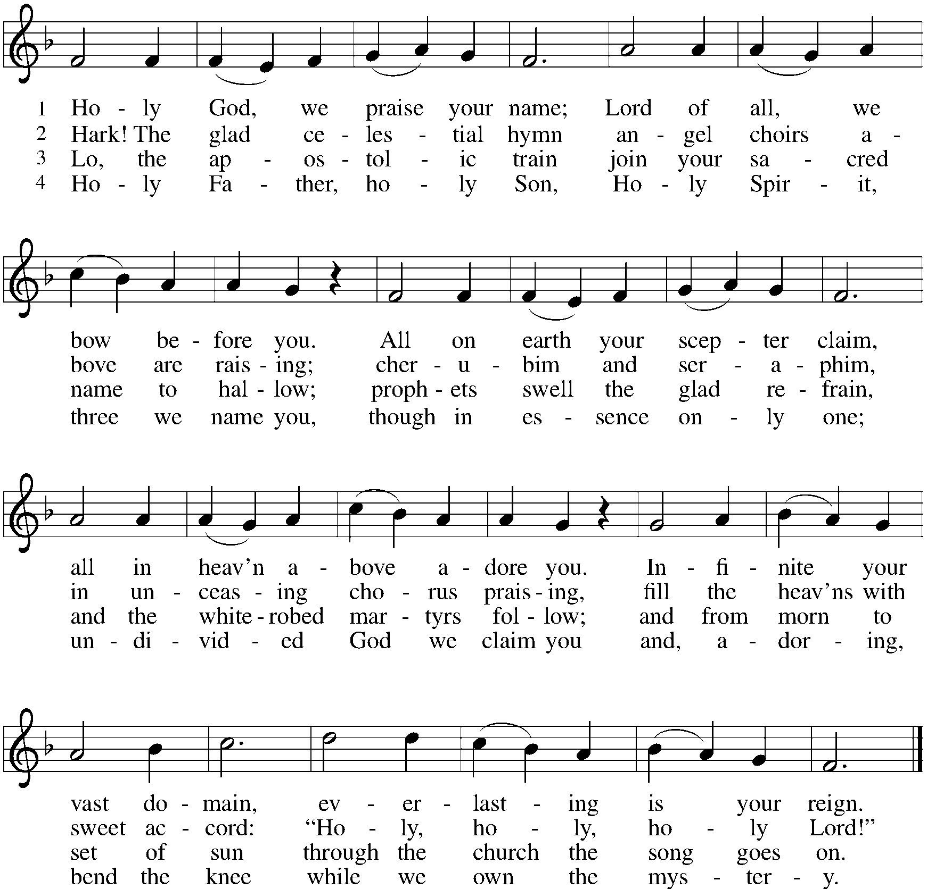
*Sent to the World
Go in peace. You are the body of Christ.
Thanks be to God.

Postlude

From Sundays and Seasons v.20190109.1233 Copyright © 2024 Augsburg Fortress. All rights reserved.
Reprinted by permission under Augsburg Fortress Liturgies Annual License #30867.
All rights reserved. Reprinted under OneLicense.net #A-718333.

Assisting in Worship Today
Worship Leader Rev. Jeffrey Koth
Pianist Sandra Venturoni
Altar Care Cheryl Huizenga
Lector Jeff Nelson
Ushers
Zoom Mark Hamilton, Jon & Cathy Milleville
Fellowship Hour Chuck & Jan Miller

Remember in Prayer
Jake Jacobson, Member, Healing & Strength
George LaRocco, brother-in-law of Jean Derrico, Healing & Strength
Erik Sudds, Member, Healing & Strength

Announcements
Grace Family Fun Day! Join us on Thursday, July 18th from 5-8pm at the West Shelter at Blackwell Foret Preserve on Butterfield Road in Warrenville. There will be paddle boats & canoes (until 6pm), games, hot dogs, s’mores & more. All are Welcome!

Beautiful Piano Recital at St. Luke Lutheran Church on Butterfield Road: On Sunday, July 14th at 3:00 p.m., Gwen and Bob Holst will present a piano recital in the Sanctuary at St. Luke. The concert will hold J. S. Bach's Goldberg Variations, Beethoven's Piano Sonata in E-Flat Major, Op. 27, No. 1 - the companion piece to the "Moonlight Sonata," Beethoven's Eleven New Bagatelles, Op. 119 and works by Faure. In addition, two major compositions for Piano Four Hands will be played: Debussy's delightful "Petite Suite" and the brilliant Fantasy in F Minor by Schubert. If you are looking for a positive way to beat the heat, don’t miss this concert. The music is wonderful, the playing is pretty good (to use a well-known phrase by Garrison Keillor) and the Sanctuary is cool. How could you spend your time better? Watch the White Sox? There will be a free will offering that will benefit the Good Samaritan Fund. We hope to see you on the 14th. Note from Barbara Sudds: Bob Holst is St. Luke’s Music Director. He and his wife, Gwen, are both accomplished pianists. The Good Samaritan Fund is the equivalent of Grace’s Angel Fund, to assist those in need. It is sure to be an incredible afternoon of beautiful music. I hope you will attend.

Music Director Search: While we are not actively conducting a search at this time, there may be a candidate you hear about whose information you want to share with Grace. Jim Kregor will be the point of contact for these inquiries. Jim’s contact information is jpkregor@juno.com.

Introducing Grace Connects: The Grace Connects task force is seeking volunteers to host activities on the 2nd Thursday and 4th Sunday of the month. With these programs, we are reaching out to engage members of our congregation, as well as our neighbors living in surrounding apartment/condo buildings and the Village of Glen Ellyn. All are invited to participate!

Do you have a talent to share, a program you've always dreamed of hosting? Join us after worship on a Sunday in July (7/14, 7/21, 7/28) to learn more about the Grace Connects program and volunteer to host an activity. Updates about scheduled activities (starting in August) will be advertised in the Grace to You monthly newsletter, the weekly bulletin, and the At Your Service Senior Center newsletter.

Senior Center Newsletter: The At Your Service Senior Center newsletter published by the Village of Glen Ellyn is available electronically at www.glenellyn.org/169/Senior-Center.

Wanted-LED Screens 50” or Larger: We would like to update several of the LED’s we have at Grace to bring in newer technology and better pictures. If you have one you would like to donate to Grace, please contact Mark Hamilton at 630-841-2941 or marham999@gmail.com. Mark will even come and pick it up from you! Thank you.

Historic Game Night - Mystery Games: Friday July 19 – 5pm to 8pm – at the Glen Ellyn History Center, 800 N. Main Street. This event, planned by the Glen Ellyn Historical Society, is for families, friends and the opportunity to make new friends at the Historic Game Night! The evening Includes a brief presentation about the evolution of mystery games given before people are welcome to try several different games at the History Center. Free event - there will be a variety of mystery games available for everyone to play at this event. www.gehs.org - 630-469-1867.

Every Member a Minister and Missionary!

Phone: 630-469-1555 Emergency Pastoral Contact: 224-355-4213
info@graceglenellyn.org www.graceglenellyn.org

Interim Pastor
Rev. Jeffrey Koth office ext. 14
revjkoth@gmail.com

Pianist
Sandra Venturoni 630-469-7614
sventuroni@sbcglobal.net

Children’s Ministry Coordinator
Cyndy Drager 630-659-4922
mmscyndy@aol.com

Office Manager
Barbara Sudds office ext. 10
bsudds@graceglenellyn.org

Parish Counselor
Carole LoGalbo M.S., LCPC 630-668-4594
carolelogalbo@yahoo.com

Custodian
Julian Mendoza

